Tacoma Bridge Collapse

Zachary Benning

Madison Sheridan

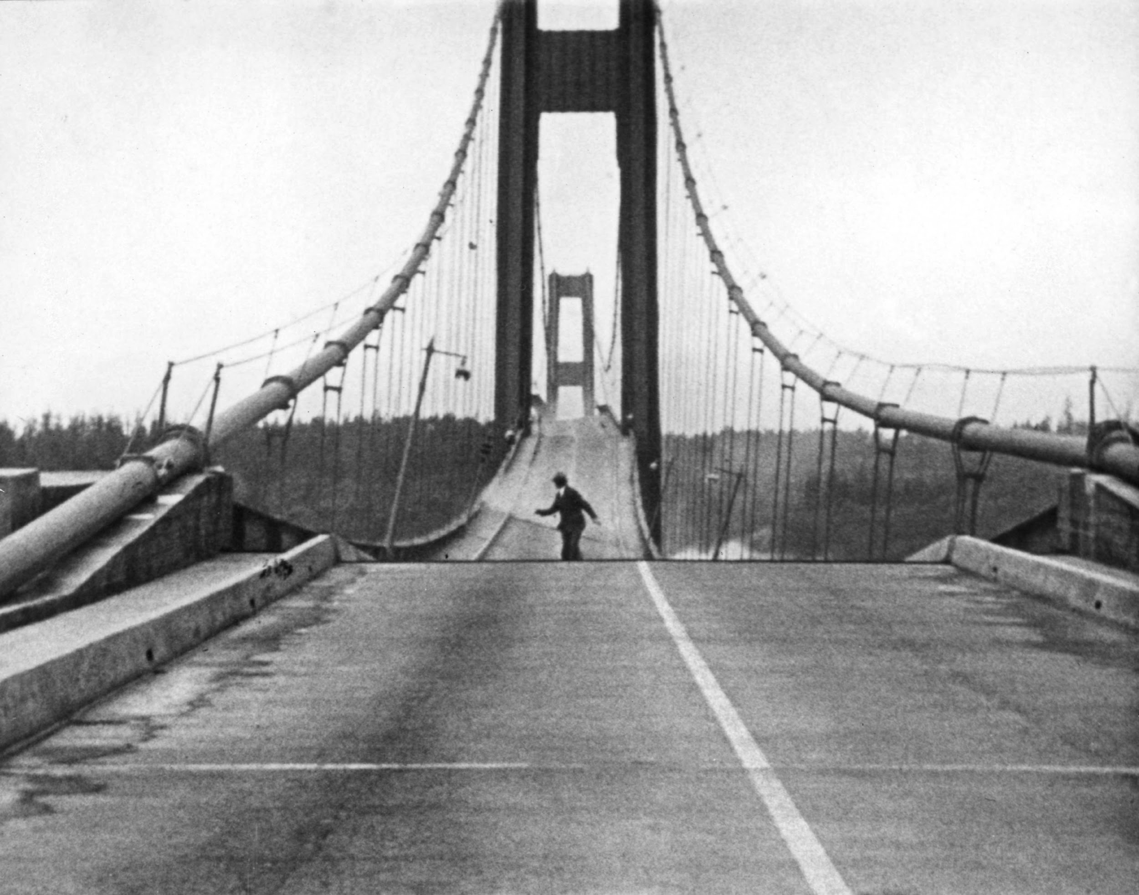

Math 412 : Scientific Computing

Dr. Chilton



2/27/17

Background

A mathematical model that attempts to capture the Tacoma Narrows Bridge incident was proposed by McKenna and Tuama [2001]. The goal is to explain how torsional, or twisting, oscillations can be magnified by forcing that is strictly vertical. Consider a roadway of width $D$ hanging between two suspended cables, as in Figure 6.18(a).We will consider a two-dimensional slice of the bridge, ignoring the dimension of the bridge’s length for this model, since we are only interested in the side-to-side motion. At rest, the roadway hangs at a certain equilibrium height due to gravity; let $y$ denote the current distance the center of the roadway hangs below this equilibrium.

Hooke’s law postulates a linear response, meaning that the restoring force the cables apply will be proportional to the deviation. Let $θ$ be the angle the roadway makes with the horizontal. There are two suspension cables, stretched $y-Lsin(θ)$ and $y+Lsin(θ)$ from equilibrium, respectively. Assume that a viscous damping term is given that is proportional to the velocity. Using Newton’s law $F=ma$ and denoting Hooke’s constant by $K$, the equations of motion for $y$ and $θ$ are as follows:

$$y''= -dy'-[\frac{K}{m}(y-Lsin(θ))+\frac{K}{m}(y+Lsin(θ))]$$

$$θ'' = -dθ' + \frac{3cos(θ)}{L}[\frac{K}{m}(y-Lsin(θ))-\frac{K}{m}(y+Lsin(θ))]$$

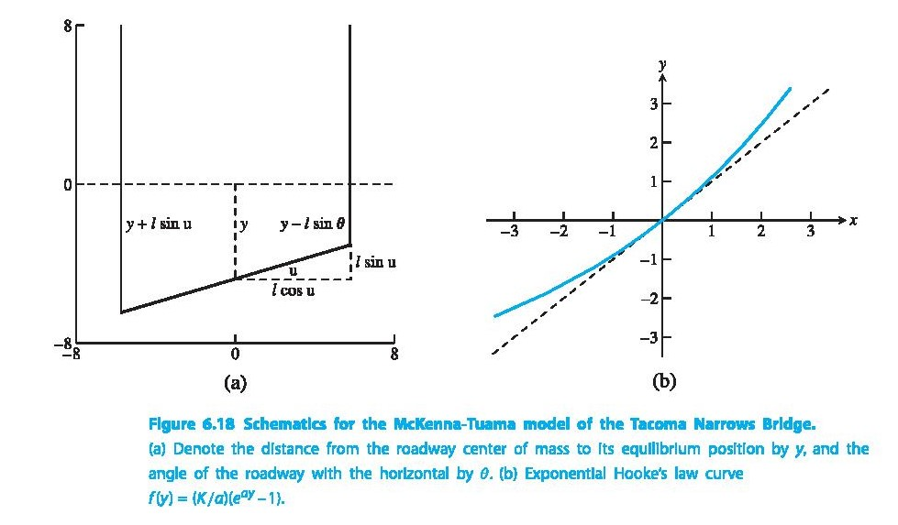

However, Hooke’s law is designed for springs, where the restoring force is more or less equal whether the springs are compressed or stretched. McKenna and Tuama hypothesize that cables pull back with more force when stretched than they push back when compressed. (Think of a string as an extreme example.) They replace the linear Hooke’s law restoring force $f(y)=Ky$ with a nonlinear force $f(y)=\frac{K}{a}e^{-ay}-1$, as shown in Figure 6.18(b). Both functions have the same slope $K$ at $y=0$; but for the nonlinear force, a positive $y$ (stretched cable) causes a stronger restoring force than the corresponding negative $y$ (slackened cable). Making this replacement in the preceding equations yields

$$y''= -dy' -\frac{K}{ma}[e^{a(y-Lsin(θ))}-1+e^{a(y+Lsin(θ))}-1]+(0.2 W sin(ω t))$$

$$θ'' = -dθ' + \frac{3cos(θ)}{L}\frac{K}{m a}[e^{a(y-Lsin(θ))}-e^{a(y+Lsin(θ))}]$$

As the equations stand, the state $y=y'=θ=θ=0$ is an equilibrium. Now turn on the wind. Add the forcing term $0.2 W sin(ω t)$ (in parenthesis above) to the right-hand side of the $y''$ equation, where $W$ is the wind speed in $\frac{km}{hr}$. This adds a strictly vertical oscillation to the bridge.

Suggested Activities:

1. Run tacoma.py using the trapezoid method with wind speed $W=80\frac{km}{hr}$ and initial conditions $y=y'=θ'=0, θ=0.001$. The bridge is stable in the torsional dimension if small disturbances in $θ$ die out; unstable if they grow far beyond original size. Which occurs for this value of $W$?

We see that the small disturbances in theta dissipate quickly and thus the bridge is stable in the torsional dimension.

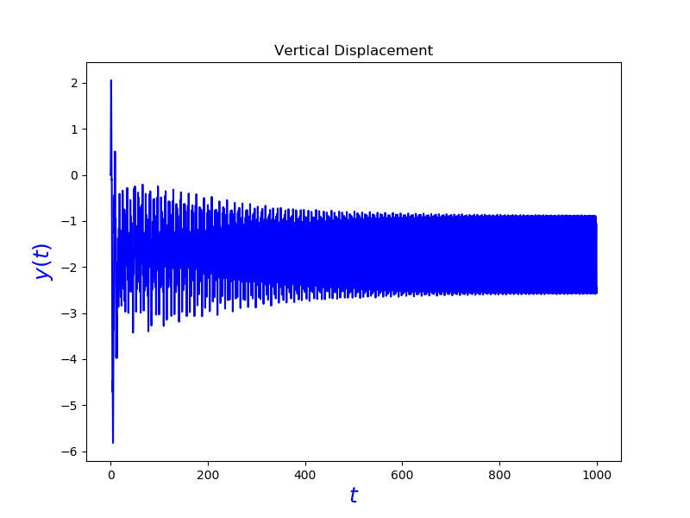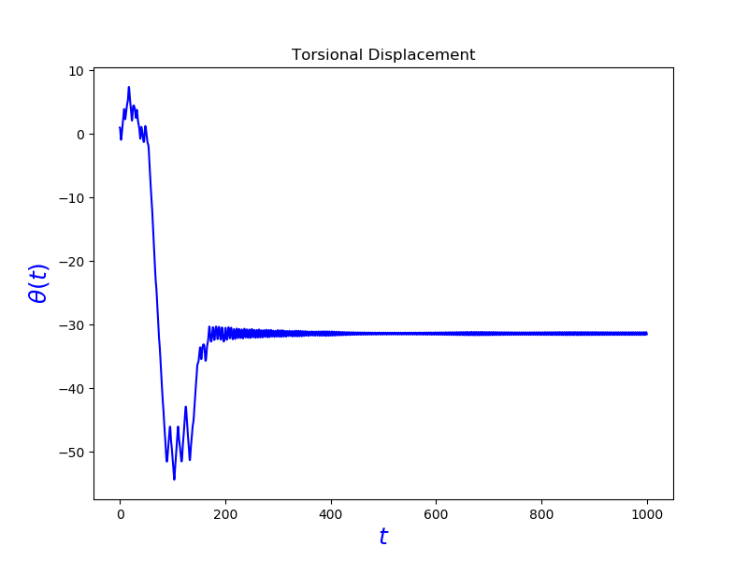

2. Replace the trapezoid method by fourth-order Runge–Kutta to improve accuracy. Also, plot $y(t)$ and $θ(t)$, for $0≤t≤1000$.

We see that the small disturbances in theta dissipate quickly and thus the bridge is stable in the torsional dimension.

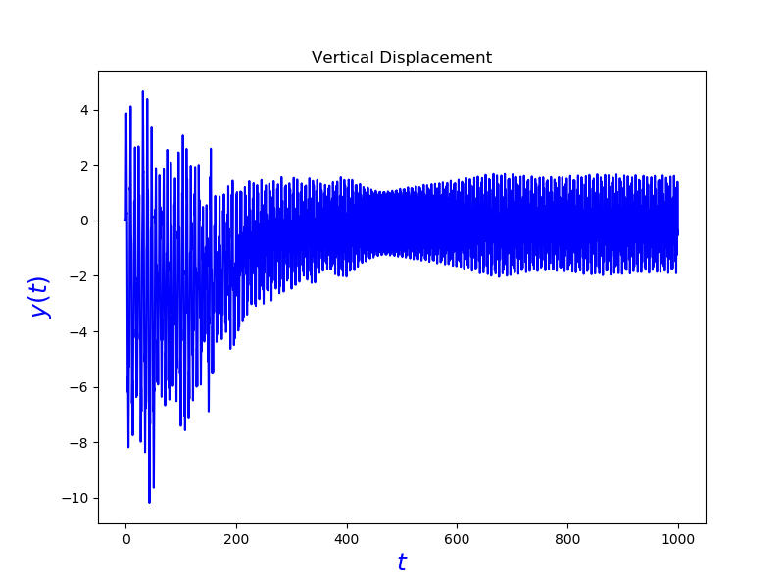

3. The system is torsionally stable for $W=50\frac{km}{hr}$. Find the magnification factor for a small initial angle. That is, set $θ(0)=10^{-3}$ and find the ratio of the maximum angle $θ(t)$, $0≤t<∞$, to $θ(0)$. Is the magnification factor approximately consistent for initial angles $θ(0)=10^{-3},10^{-4},10^{-5},10^{-6}$?

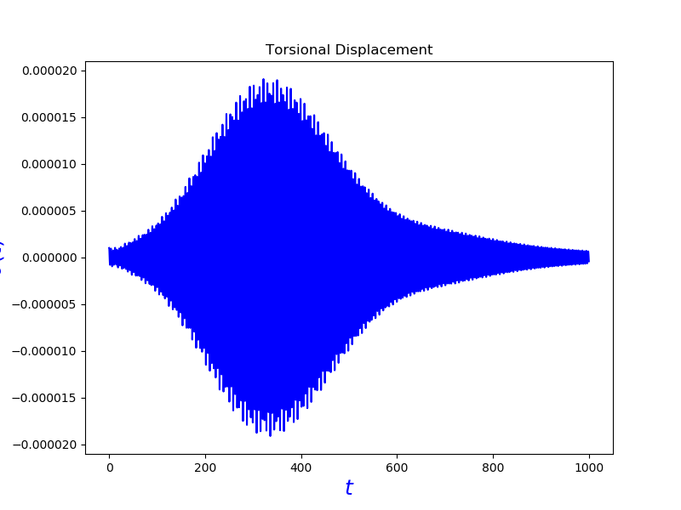

|  |  |
| --- | --- |
| Initial angle $θ(0)$ | Magnification Factor |
| $$10^{-3}$$ | 19.184910 |
| $$10^{-4}$$ | 19.056724 |
| $$10^{-5}$$ | 19.055435 |
| $$10^{-6}$$ | 19.055422 |

4. Find the minimum wind speed $W$ for which a small disturbance $θ(0)=10^{-3}$ has a magnification factor of 100 or more. Can a consistent magnification factor be defined for this $W$?

We found $W=59.0$ to be the minimum wind speed for which a small disturbance $θ(0)=10^{-3}$ has a magnification factor of 100 or more. A constant magnification error is found to be .

5. Design and implement a method for computing the minimum wind speed in Step 4, to within $0.5×10^{-3}\frac{km}{hr}$. You may want to use an equation solver from Chapter 1.

We used the bisection method to calculate $W$ to be $58.9926$ in $7$ iterations.

6. What is the effect of increasing the damping coefficient? Double the current value of $d$ $(to d = 0.02)$ and change $ω$ to $3$ to adjust for the new $d$. Compute the new critical $W$ (when the magnification factor exceeds $100$) and compare to the critical $W$ associated with $d=0.01$. Can you suggest possible changes in design that might have made the bridge less susceptible to torsion?

After an increase in the damping coefficient, it produced a value $W=26.5610$ which is approximately half of the original $W$ with respect to the original given values. Thus we suggest to minimize the $d$ value to increase the minimum critical wind speed threshold.

Works Cited:

NOTE: Work done as a collaborative effort by Madison Sheridan and Zachary Benning.

1. Sauer, Tim. Numerical analysis. Pearson, 2006.
2. writer, Derrick Nunnally Staff. “The man blamed for the fall of Tacoma's Galloping Gertie.” Theolympian, The Olympian, www.theolympian.com/news/local/article42065382.html.